**CoffeeNow Evaluation**

**Analytical Evaluation:**

The goal of this analytical evaluation is to better understand the efficiency of the interface as it is currently constructed. The main task we wanted to cover with our prototype CoffeeNow application evaluation was whether our interface provided an efficient method for both customizing and ordering a cup of coffee from the user’s favorite coffee shop.

In order to obtain a clear metric by which to judge how a skilled user would use our application to place an order for a personalized cup of coffee we used GOMS/KLM. This analysis method provided us with an accurate metric to measure how efficiently a skilled user orders a cup of coffee with the app. This is accomplished by measuring both the time and effort that must be exerted by the user to achieve their goal.

For this analysis we made the assumption, based on our interviews and observations, that our target demographic included both males and females which own a smart phone and drink coffee regularly. Obviously from this description our application will potentially have a large target demographic. So to keep much of the complexity involved with individual differences we decided that measuring the time it takes users to order a Dutch flavored coffee, with a shot of espresso, with cream and sugar, would be a valid use case.

In particular, we wanted to get an accurate time measurement for placing an order to better understand and compare this value with that of the average time our users would spend ordering a cup of coffee in the regular way. Viewing the difference in time would allow us to better understand whether we were in fact solving the problems presented in our project proposal. Namely, the large amounts of time wasted waiting in line to order.

Further, we analyzed how easy the overall process was for a skilled user. The main criterion that we used for this evaluation was both the time it took and the number of steps (i.e. button presses) that were needed to complete the task of ordering a cup of coffee.

The tool that we used to perform the analytical study was CogTool. We used the built in GOMS/KLM measurement to better understand the time and the total number of steps that were involved for a skilled user to order a cup of coffee. Using CogTool and our prototypes we created a script that measured both the total time and the total number steps (and button presses) involved for the user.

So from having our skilled user (one of our team members) using our prototype interface in CogTool we collected the following data:

Using the GOMS/KLM procedure with an average think time of 1.2 seconds for a skilled user we found that a total of 14 button presses were needed to select the pick-up location, select regular coffee with a Dutch blend, along with regular cream and sugar, and a shot of espresso and finally place the order. The figure below shows all the intermediate steps executed in the script.

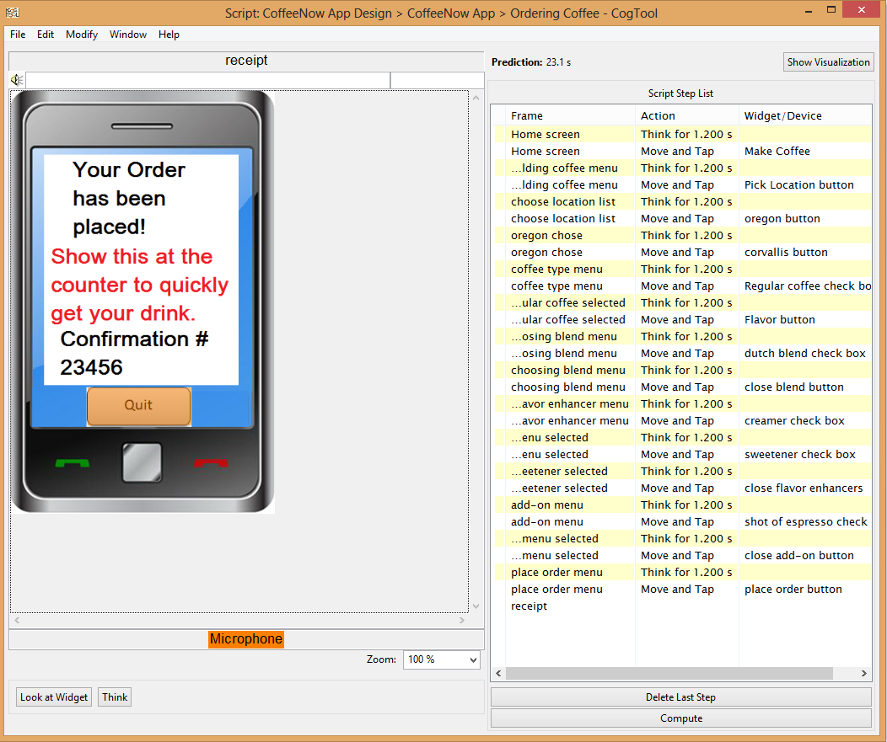

To place this order we found that on average it would take a skilled user approximately 23.1 seconds in total. Looking back to the data from our interview and observations, we can see that it indicated that the average wait time for users to wait in line to place their order was around 3 minutes with an additional 2 minutes waiting for the order to actually be fulfilled. With our application we found that we would be saving users an average of,

5 minutes – 23.1 seconds = 4 minutes and 36.9 seconds

Furthermore, assuming that our users order coffee at least 3 times a week, as indicated by our observations and interviews, we would be saving our users a total of 13 minutes 50.7 seconds on a weekly basis. This analysis of course does not include the additional benefits received if a user orders more than one cup of coffee in a typical day.

Overall, our application provides our users substantial time savings especially when extrapolated throughout a typical user’s lifetime. Likewise, the number of steps at, 14, while longer than we would have liked, was provided to the user in a wizard-like format helping the user to recognize and get used to the screens and the order in which they occur to help them navigate the interface more quickly. Hence, from our time and number of steps evaluation we feel that analytically speaking our project solves the problems our users were having with wait times at coffee shops.

**Empirical Evaluation:**

Research Goal

The goal of our usability study was to test the prototype of the CoffeeNow app with users.

Method

We used the “think-aloud” technique to evaluate whether our application works by answering the following research questions:

* Did users place their order successfully in the CoffeeNow app?
* Did users stop at any steps and ask questions? If yes, what did they ask?
* Did users make any comments on the features/labels while they were using the application? If yes, what are their comments?
* Do users think the app save their time?
* Do they see themselves using this application if it is available? Why/Why not?

The “thank-aloud” technique was chosen because we wanted to observe how users use our prototype and gain a better understanding of their thinking process.

Participant

We randomly selected one male and one female from our previous research/interview assignment. Both participants are in their late 20s/early30s, drink coffee regularly, and own a smart phone.

Prototype Tool

CogTool demo

Procedure

Each participant was interviewed by one of our team members. Both participants used the CoffeeNow application to order a Dutch flavored coffee, with a shot of espresso and with cream and sugar. They talked constantly as they did the task. After they completed the assignment, they answered three follow-up questions. Our team members recorded all the questions and comments the participants had about the application. Both interviews lasted about 10 minutes.

Data

See the CoffeeNow Evaluation Appendix for our interview data.

Result

All of our research questions are addressed in our protocol analysis.

* Both users placed their order successfully in the CoffeeNow app.
* Users found the task confusing when proceeding from step 3 to step 4.
* One of the labels (i.e., “anything”) in step 4/Flavor Enhancer is unclear to users.
* Users think our application is missing some important features and suggest to add the following:

1. An option to choose the size for their drink
2. An option to choose the amount of flavor enhancer
3. An option to order non-coffee items (e.g., food/tea/water)
4. An option to go back to the previous steps
5. An option to choose the pick-up time
6. Add more choices (e.g., honey or agave) to Flavor/Enhancer (step 4)
7. Add a page dedicated to the options available in the add-ons
8. An option to add comments
9. Display a message to inform customers how they can retrieve their confirmation number
10. Let customers know how they can pay for their order

* One user thinks the app would save her time, whereas the other thinks it might if there is a special line for online ordering.
* One user said she would use our application if it is refined. The other indicated he would use it if he can save time and the coffee is fresh at pick-up.

Insight for our prototype

* We can enhance our prototype by including the options our participants recommended (e.g., option for customers to choose the size of their drink, the amount of flavor enhancer, pick-up time; and allow them to go back to the previous steps to edit their order)
* We need to add an icon (e.g., “next” or “ok”) to the bottom of each screen, rather than having users to tap the top bar to enter their selection.
* We need to change the unclear label and add more choices in step 4/Flavor Enhancer.
* We can provide an open-box for users to add their comments.
* We need to improve the visibility of the confirmation number location so users know how to retrieve it.